“Lack of education about Parkinson's and poverty are two epidemics affecting care of Parkinson’s patients around the globe” – Dr.Rana
“SPONSOR TREATMENT OF ONE PARKINSON’S PATIENT” AFFECTED WITH POVERTY WHO CAN’T AFFORD MEDICATIONS

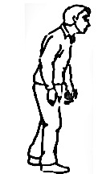
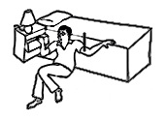
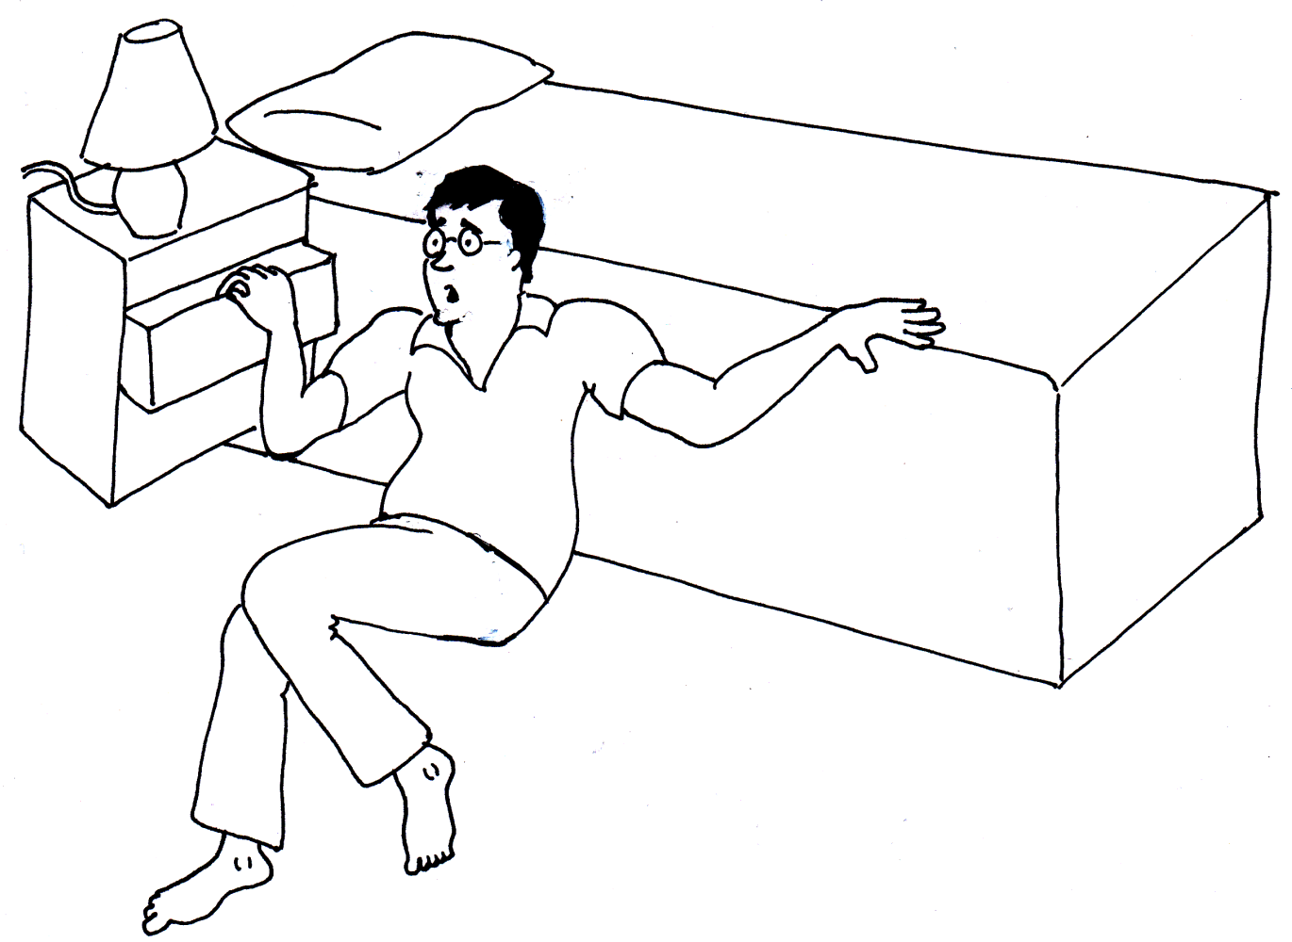
Parkinson’s disease is a disabling neurological condition with tremor, slowness of movements, balance problems and many other symptoms such as dementia, drooling, falls, speech or swallowing difficulties, and hallucinations. There is no cure available for this disease; patients have to take medications for lifetime for their day-to-day function.
Millions of Parkinson's patients in various parts of world are not able to afford buying medications and suffer with falling, become bedridden, dependent and immobile leading to mortality.
We provide Parkinson’s disease medications, canes, walkers, wheelchairs, educational literature in local languages to these patients free of charge. By donating every month, you can sponsor treatment of a Parkinson’s patient. We thank you dearly for your monetary contribution. Please print and complete this form then mail original form to:
World Parkinson’s Program, 18 Bloomsbury Street, Whitby, ON, Canada L1M0H6
FOR DONATING BY CREDIT CARD
DONOR INFORMATION
Date:_____________________________
Name: _____________________________________________________________________________

Billing Address: ______________________________________________________________________

City: ________________ State/Province: _______________ Postal Code: _________________

Country: _____________Telephone: ______________ E-mail: _____________________________
DONATION TYPE
OPTION 1: Charge my credit card each month by the donation amount.
OPTION 2: One-time donation
PAYMENT DETAILS : Please check-mark the applicable box:

$1000 $500 $400 $300 $200 $100 $75 $50 $25 Other: $ ____________________________

Visa Master Card American Express Discover

Credit Card #:________________________________________________ Expiry Date: ______________

Name on Card: ____________________________ Signature: __________________________________

* An official receipt will be issued for all donations of $50 or more, or upon request.

