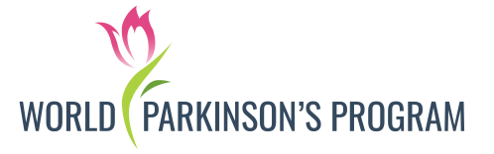**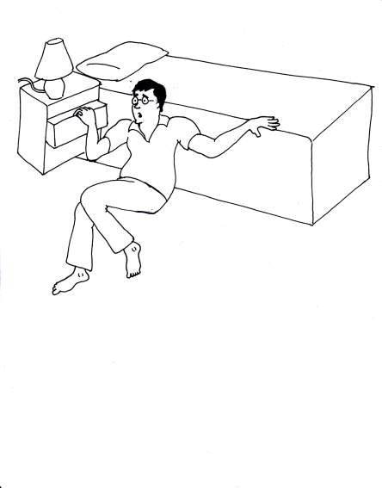***“*Lack of education about Parkinson's and poverty are two epidemics affecting care of Parkinson’s patients around the globe” – *Dr.Rana*

**“SPONSOR TREATMENT OF ONE PARKINSON’S PATIENT” AFFECTED WITH POVERTY WHO CAN’T AFFORD MEDICATIONS**

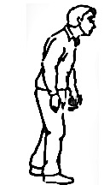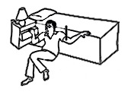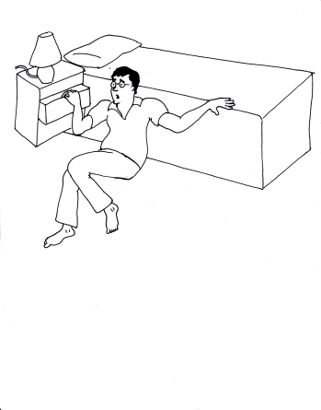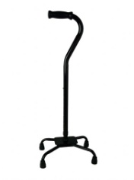Parkinson’s disease is a disabling neurological condition with tremor, slowness of movements, balance problems and many other symptoms such as dementia, drooling, falls, speech or swallowing difficulties, and hallucinations. There is no cure available for this disease; patients have to take medications for lifetime for their day-to-day function.



Millions of Parkinson's patients in various parts of world are not able to afford buying medications and suffer with falling, become bedridden, dependent and immobile leading to mortality. 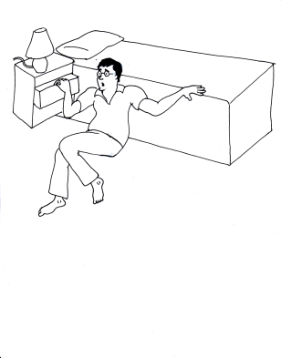



We provide Parkinson’s disease medications, canes, walkers, wheelchairs, educational literature in local languages to these patients free of charge. By donating every month, you can sponsor treatment of a Parkinson’s patient. We thank you dearly for your monetary contribution. Please print and complete this form then mail original form to:

**World Parkinson’s Program, 18 Bloomsbury Street, Whitby, ON, Canada L1M0H6**

**FOR DONATING THROUGH BANK ACCOUNT**

Date:______________________________

I would like to support World Parkinson’s Program through monthly donations.

Please debit my bank account: (attach VOID cheque)

$1000 $500 $400 $300 $200 $100 $75 $50 $25 Other: $ _________________(specify)

Signature: ____________________________________________________

Donor Name: ____________________________________________________

Address/ Contact Information: ____________________________________________________

____________________________________________________

Phone: _________________________ E-mail________________________________________

This donation is made on behalf of: _________an Individual _________a Business

*I may revoke my authorization at any time, subject to providing notice of 30 days. To obtain a sample cancellation form, or for more information on my right to cancel a PAD Agreement, I may contact my financial institution or visit* [*www.cdnpay.ca*](http://www.cdnpay.ca)*.*

*I have certain recourse rights if any debit does not comply with this agreement. For example, I have the right to receive reimbursement for any debit that is not authorized or is not consisted with this PAD Agreement. To obtain more information on my recourse rights, I may contact my financial institution or visit* [*www.cdnpay.ca*](http://www.cdnpay.ca).

1*-2060 Ellesmere Rd. Toronto, ON, Canada M1H 2V6.For account inquires contact* [finance@pdprogram.org](mailto:finance@pdprogram.org)[*www.pdprogram.org*](http://www.pdprogram.org)